**PROJECT REPORT**

**1. INTRODUCTION**

**1.1. OVERVIEW**

The project in the zoho books for UrbanAura Interiors involves the creation of financial statement, which includes income statement, balance sheet and cash flow statement these statement are essential to assess the financial wealth of the company.

**1.2 PURPOSE**

By creating a financial statement In the zoho books we can gain deep understanding of our company’s financial standing and make strategic adjustments to improve your performance and it helps in identify the trends.

**2. PROBLEM DEFINITION & DESIGN THINKING**

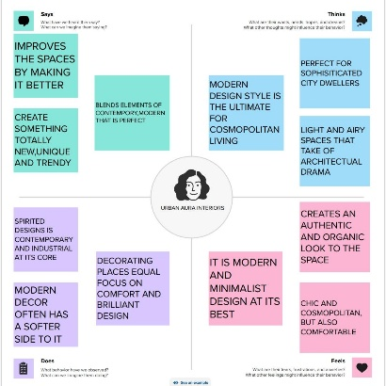**2.1 EMPHATHY MAP**

**2.2 IDEATION & BRAINSTROMING MAP**

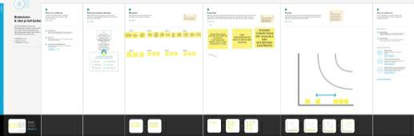

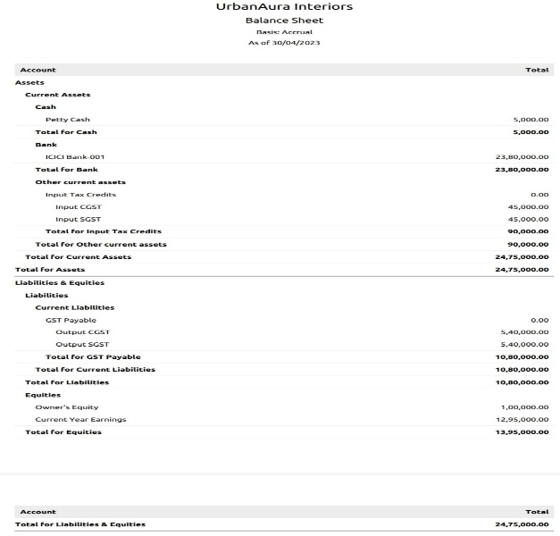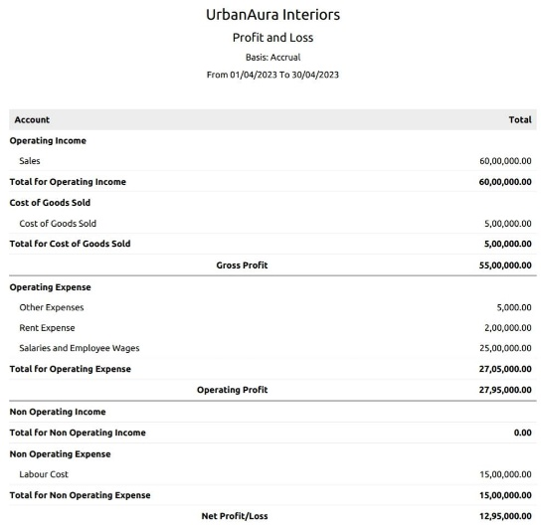**3.RESULT**

**4.ADVANTAGES & DISADVANTAGES**

**Building Design:**

Building design includes both the architecture and design of specific buildings found in urban settings. It is an essential component of urban design that has a big impact on the general feel and standard of a street or neighbourhood.

**Accessibility**:

Accessibility describes how easily and conveniently people can travel around a city. This includes a variety of components that promote mobility in metropolitan settings, including sidewalks, bike lanes, and other infrastructure.

**DISADVANTAGES**

**Scaling**

Scaling is when an interior designer combines various elements in an interior space to give it the illusion of height and space.

**Selling Design Ideas**

Another biggest challenge that design professionals face is getting their ideas across to clients. As a designer, one may have numerous design ideas, but if one is unable to get them across to the client, the idea can fall flat.

**5.APPLICATIONS**

Zoho Books can also be applied in other Areas , including:

**Own Strength**

Each home has its own strengths that a thoughtful interior design concept can and will highlight. Form and function have to be balanced; every project is a journey from thought to reality. Each room is considered part of the whole.

**Communication skill**

Each client communicates in their own unique way.as the client, narrow down the right interior design styles you gravitate towards, which informs the design of a room.

**6.CONCLUSION**

To summarize the project done in Zoho Books on financial statements, the Following can be presented:

All three financial statements generated Using Zoho Books will give an overview of UrbanAura Interiors, which Will help the management make informed Decisions to improve the company’s Profitability and sustainability.

**7**.**FUTURE SCOPE**

**MISSION**

Mission is to deliver a project that is a true reflection of the client’s vision. Commitment to detail and budget-saving efficiency is what makes us different.

**CREATIVE**

Continually deliver creative and functional spaces that go beyond our client’s needs and expectations. Although each project has its own challenges, our processes can adapt quickly so that, together, can deliver a successful result on time and within budget.